**Money, Faith & Worship:**

                                   Year-to-Date                       Prior Year              Variance

Revenue                          $31,403                         $29,943                 $1,460

Expenses                           37,003                           33,964                   3,039

                                         $(5,600)                         $(4,021)                $(1,579)

September is showing a deficit for the 3 month period of $5,600, which has caused us to be really tight on cash again.

The River still has a GIC of $8,315, which will need to be redeemed unless any major donations come in.

For those who write cheques, we are supposed to let you know to please make cheques payable to “The River Church” or “The River Squamish BC”.

**City Wide Gathering**

**November 2019**

River Kids Program

Little Dippers Pre-School Program

Service Starts 10:00 am



**River Church Wish List**

*For Those of Who Look For Creative Ways to Give Over and Above Your Regular Giving*

* Mini-Portable Speaker $750
* Gift to Cover Faith Budget $21,000
* Fund for Part-Time Admin Person $20,400
* Office Rent in High Traffic Area $7,200

Please mark your Calendars now!

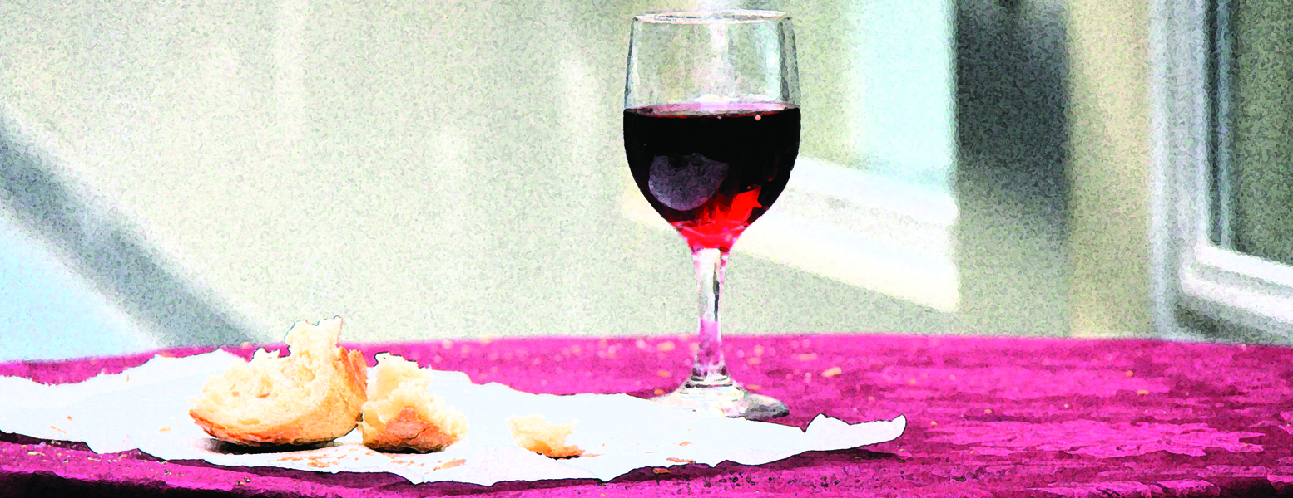

**About Us:** The River Churches’ guiding ideas are these: ‘GET REAL’ **G**race-Filled, **E**ngaged, **T**ruthful, **R**elational, **E**xperiential, **A**uthentic, **L**oving. One way we live this out, is by embracing a Simple Church Hybrid Model. The 1st and 3rd Sunday of each month we gather together in smaller gatherings, called Simple Churches. One of which, meets at Don Ross Secondary School (DRSS). On the 2nd & 4th Sunday we host what is called a CWG (City Wide Gathering), where all the Simple Churches gather together at DRSS. This allows us to GET REAL and be the kind of people God has called us to be in this community. When we have a 5th Sunday in a month, we do something we call “Brunch Sundays”. The early church was said to have regular times where they gathered to break bread, and enjoy a meal together. These Brunch Sundays are our attempt at making that happen. To learn more about what makes The River unique, please check out our website at [www.intheriver.ca](http://www.intheriver.ca)

**Mission Statement:** We are a network of Simple Churches, immersed in the grace of God, created to be rivers of life (rivers of healing / rivers of mercy / rivers of kindness etc.) to our city and beyond.

**Our Vision:** Our Vision is simply…Jesus. Apprentices of Jesus, creating apprentices of Jesus who live by faith, are known by love, and a voice of hope.

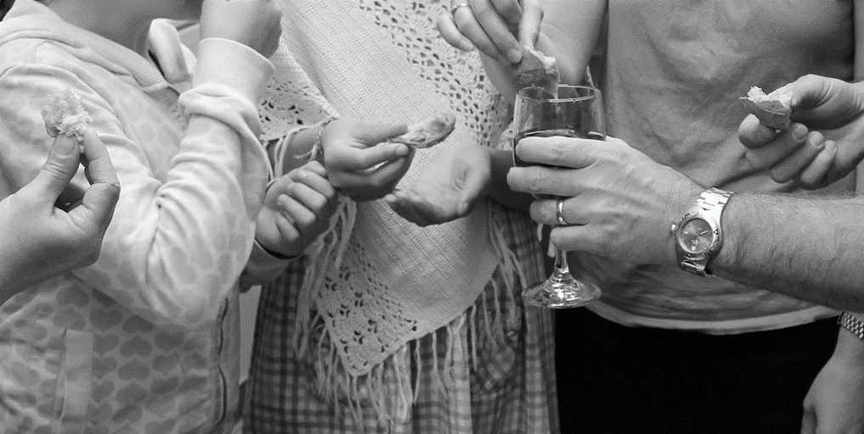

**www.intheriver.ca**

**www.intheriver.ca 604.848.8007**

**Mailing Address:**

PO Box 665

Brackendale, BC

V0N 1H0

**Office/Study Location:**

41371 Kingswood Road

Brackendale

Pastoral Staff: Darcy & Kenda Reimer

d. [darcyr@intheriver.ca](mailto:darcyr@intheriver.ca) k. [kendar@intheriver.ca](mailto:kendar@intheriver.ca)

d. 604-848-8007 k. 604-848-8227

Pastor

`

**Fueling Thought**

“Yes, Jesus hung out with prostitutes and drunkards and outcasts. Here’s the thing though, by the time Jesus was finished with these people, they weren’t prostitutes or drunkards or outcasts anymore.

Jesus came to transform people, not indulge them. Christianity is about surrender, not comfort. We are to align ourselves to His standard, not the other way around.”

Kenneth Valardi

**Hearing God Deep Stream** January 17th & 18th (Friday 7:30 – 9:30 pm / Sat 9:00 am to 12 noon). Everyone welcome.

**Encounter Freedom Deep Stream** in May 1st & 2nd (Friday 7:30 – 9:30 pm & Sat 9:00 am to 12 noon). All Church and leadership encouraged to attend.

**Blazing Falcons:** Events where it’s all about having fun! Stay tuned for upcoming dates through winter months. A component of this will be to encourage men and women to be a part of a triad that meets 2X per month, but that comes later.

To hear more contact Pastor Darcy & Kenda

**Hymn Service at Hilltop:**

2-3pm @ Hilltop House. Contact Dorothy Wikkerink to find out when the next event is [dorothyrenema@hotmail.com](mailto:dorothyrenema@hotmail.com) or 604-849-6205 for more info.

**Month of Prayer:** January 1st to January 31st. More informationcoming!

**Helping Emily & Kyle Moving:** The Harris’ are moving on Nov 16th and would love some help. So please talk to Emily or the Bents to find out more info.

**Christmas Shoebox:** October 13th to Nov. 24th – boxes available on by the book table. Drop off at NSAC in North Vancouver

**Totem Hall Christmas Dinner:** December 21st so please mark your calendars! Let’s all get involved. What a great way for us collectively to live out our mission – known by love, live by faith, voice of hope.

**Christmas Eve Candlelight Service:**

Brackendale Art Gallery 5 – 6 pm

Don Ross Secondary School 6:30-7:30 pm

**Children and Youth Programs**

**Vision:**  For kids to have a safe place where they know God’s love, learn what it means to be like Jesus and experience the power of the Holy Spirit in their lives.

**Leaders:** All teachers in our children’s programs are members of the River Church and have completed criminal record checks. For safety, we follow the policies and procedures outlined in Plan to Protect. For questions, comments or to volunteer, contact Kenda Reimer at [kendar@intheriver.ca](mailto:kendar@intheriver.ca)

**Little Dippers (infant to school age):** We have teachers on a rotation however, parents are welcome to stay with their children if need be. The format we use is story, pray, play. Whenever possible we use the carpeted room beside the main meeting space. If unavailable, we set up inside the hallway across from the gym. If you would like to be on this rotation, contact Kenda.

**River Kids (kindergarten to Gr.6):** The kids are dismissed after the singing. River Kids runs only on the 2nd and 4th Sundays of each month. On the 1st and 3rd weeks we strive to make the service inclusive for all ages. We encourage children to participate with the adults wherever they are meeting.

**Young Life (Gr.7 to 12):**

If you’re a teen ages 13-18 and looking to connect with other youth city wide who follow Jesus or are interested in Jesus please contact Allyson Huguet, our Young Life Leader for Squamish at [www.facebook.com/pages/SquamishYoungLife](https://www.facebook.com/Squamish-YoungLife-196070930416603/).

**Global Missions**: Part of your general giving helps to fund Canadian CMA missionaries worldwide. We had a link agreement with Gaileen but she is now retiring. We are in discussion with other missionaries we know to start a relationship with them. We are excited about what this new partnership could look like.

**Simple Churches**

**Tantalus:** 5:30–8:30pm Contact: Richard [richard.hoshino@gmail.com](mailto:richard.hoshino@gmail.com) and Karen Hoshino [kareninnara@yahoo.ca](mailto:kareninnara@yahoo.ca) [mail4jimn@gmail.com](mailto:mail4jimn@gmail.com) or 604-892-4256

**Paradise Valley:** 10am, ending with a meal @ Rolf & Christine Rutishauser’s in Paradise Valley. [rcruti@gmail.com](mailto:rcruti@gmail.com)

**Growth Streams**

**Women’s Group:** We will again be meeting in triads bi-weekly and all together monthly. If you want to be part of a triad, please let me know this week as I want to put the groups together right away. I’m also looking for someone to help plan our fun group meetings. If you have any questions or would like to help contact Kenda kendar@intheriver.ca

**Men’s Group:** 2nd & 4th Mondays of each month. 7:30pm Contact Jim or Richard [www.intheriver.ca/community/mens-group](http://www.intheriver.ca/community/mens-group)

**Listening Prayer Ministry:** Are you feeling stuck? What if Jesus wants to come alongside and speak into that? Listening Prayer is wonderful for encouragement, inner healing and giving all burdens to Jesus – they were never meant to be carried alone. Contact Pastor Kenda or Darcy, or Claudia [claudiauweiland@gmail.com](mailto:claudiauweiland@gmail.com)

**Tuesday Bible Study** through 1st & 2nd Peter & Jude / started Sept 17th so not too late to join Contact Steve Klassen at [**sklassen@telus.net**](mailto:sklassen@telus.net)

**Tuesday morning prayer**

10:30 am the 1st and 3rd Tuesdays of each month at Maria Shemko’s 40119 Garibaldi Way. Contact Kenda for more details.

**News & Events**

**Living Out Jesus’ Love**